**MANUSCRIPT DRAFT**

**Modality Matters: Prediction of Cognitive Outcome Using Brain Age Derived from Different Modalities**

E. Doering1,2, G. Antonopoulos3,5, M. Hönig1,4, T. van Eimeren1,2, S. B. Eickhoff3,5, K. R. Patil5,5, A. Drzezga1,2,4 for the Alzheimer’s Disease Neuroimaging Initiative[1]

1University Hospital Cologne, Clinic and Policlinic for Nuclear Medicine, Cologne, Germany, 2German Center for Neurodegenerative Diseases, Positron Emission Tomography, Bonn, Germany, 3Research Center Juelich, Brain and Behavior (INM-7), Juelich, Germany, 4 Research Center Juelich, Molecular Organization of the Brain (INM-2), Juelich, Germany, 5Heinrich-Heine-University, Institute of Systems Neuroscience, Duesseldorf, Germany

Keywords: biological age, machine learning, Alzheimer’s disease

Objectives: Brain aging is characterized by anatomical and molecular changes. Deviations from the normal aging trajectory in the form of advanced brain aging relative to chronological age (“brain age gap”, *BAG*) is associated with cognitive decline. Such normal aging trajectories are typically estimated from magnetic resonance imaging (MRI), however, changes in neuronal glucose metabolism, visible on 18F-Fluorodeoxyglucose positron emission tomography (FDG-PET), likely precede anatomical changes observed on MRI. Here, we compare the accuracy of brain age estimation from FDG-PET and MRI, and we associate BAG derived from both modalities with cognitive impairment, and Alzheimer’s disease biomarkers. Furthermore, we present thresholds for the prediction of cognitive decline from BAG. Analyses were conducted in individuals without (CN) and with mild cognitive impairment (MCI).

Methods: Machine learning algorithms were trained to estimate brain age from 367 matched MRI or FDG-PET scans of CN from the Alzheimer’s Disease Neuroimaging Initiative using a nested cross-validation approach. BAG was computed and correlated with measures of amyloid and tau pathology in CN and MCI (n=513). Finally, BAG was used to predict a change in individuals' cognitive diagnosis after two years using cross-validated logistic regression. Thresholds for cognitive decline were estimated from the logistic regression output.

Results: FDG-PET (MAE=2.46 years) and MRI (MAE=1.96 years) both predicted chronological age well. XX

FDG-PET-derived BAG was more strongly associated with measures of amyloid in CN, whereas MRI-derived BAG correlated better with measures of cerebral amyloid and tau in MCI. In CN, FDG-PET-derived BAG significantly predicted cognitive decline, while both FDG-PET- and MRI-derived BAG were associated with an AD diagnosis after two years in MCI, however associations were stronger in MRI.

Conclusion:

Brain age is reliably estimated from FDG-PET or MRI. Amyloid-neuropathology, predisposing for Alzheimer’s disease, is related to features of advanced BAG in FDG-PET ahead of clinical onset of disease, and 18F-FDG-PET-derived BAG reliably predicts cognitive decline in CN. Onset of tau-related neurodegeneration and of pending conversion to AD is more strongly associated with increasing BAG on MRI.

**Graphical Abstract**

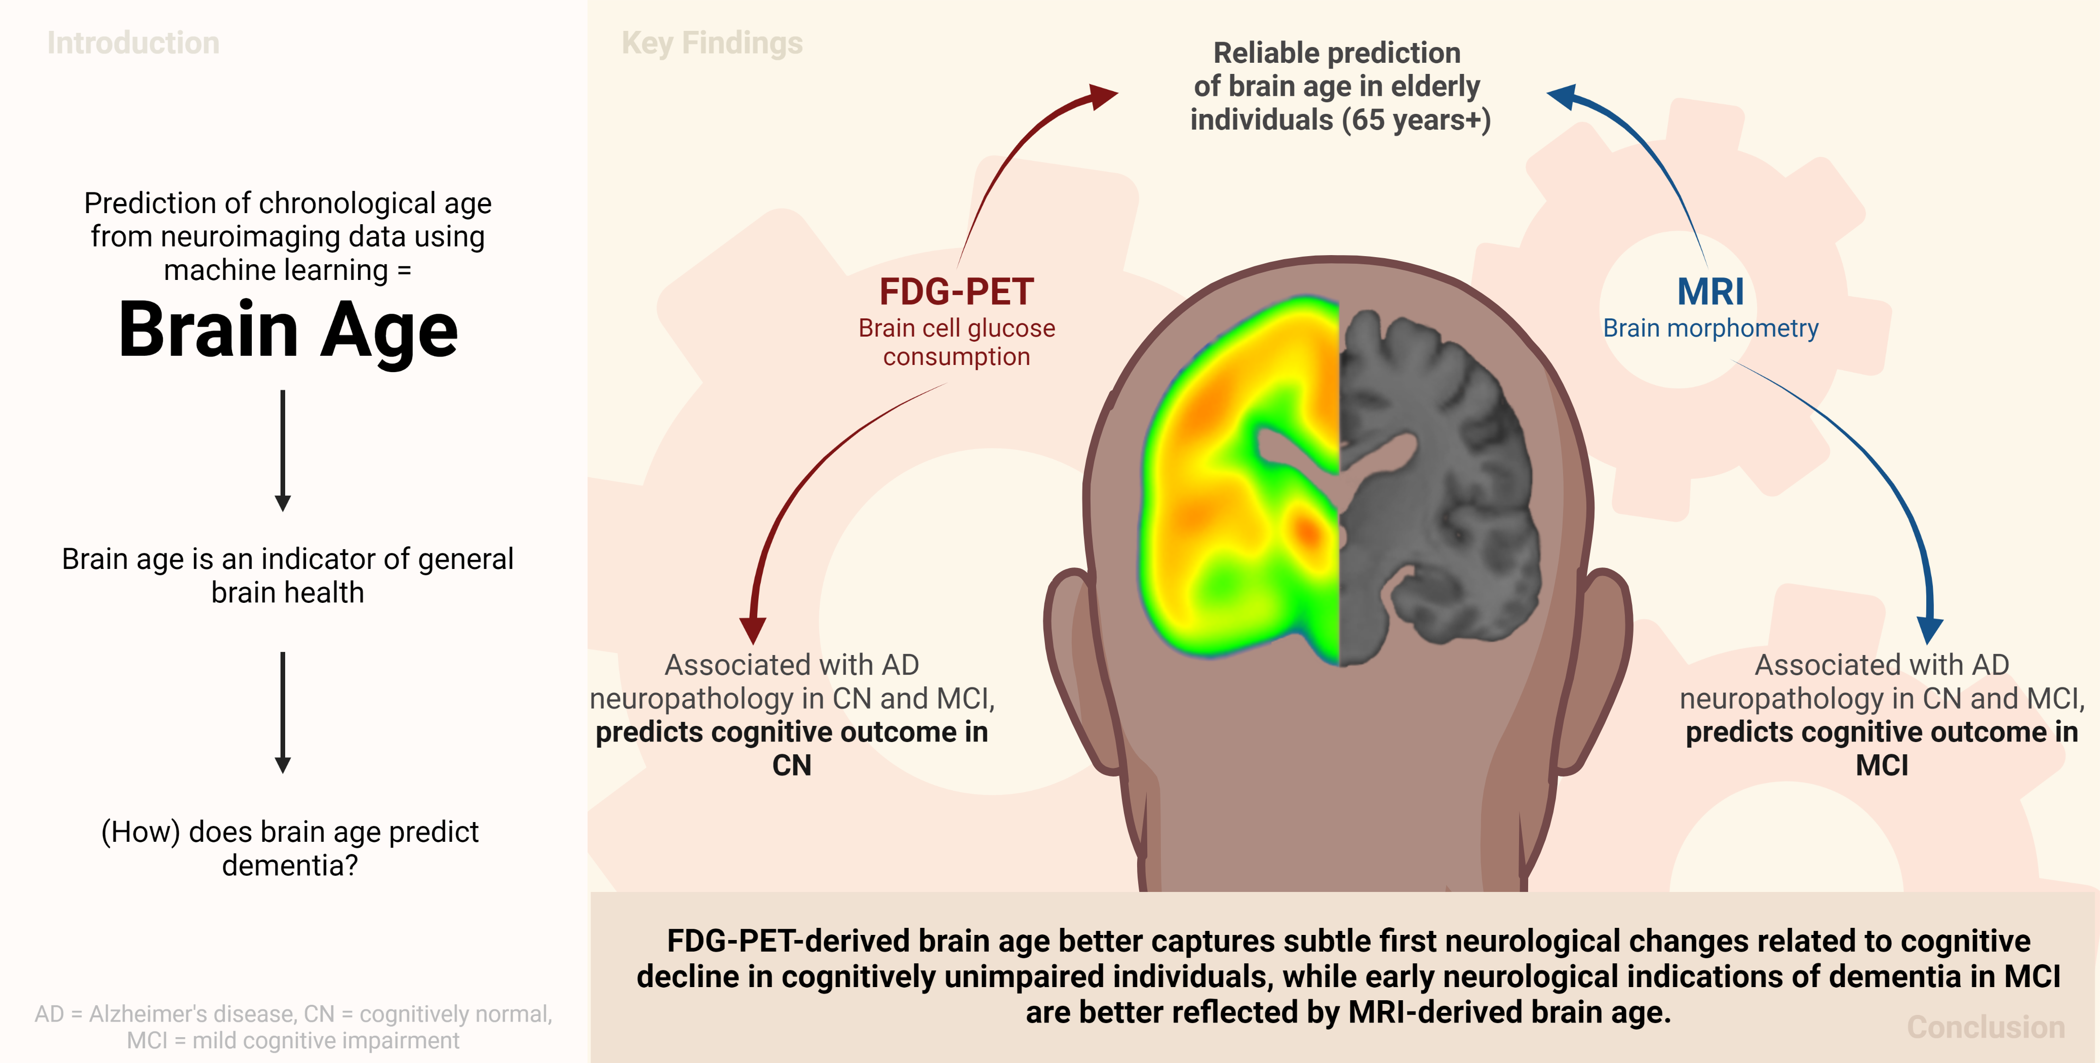

**1 Introduction**

Biological aging entails the change in or decline of various physiological functions. Human biological aging, as opposed to chronological aging, differs depending on the tissue under investigation – and advanced biological age of specific organs is associated with diseases of the same1. Biological age of the brain, i.e., *brain age*, is modeled via machine learning algorithms by predicting a person’s chronological age from their neuroimaging data. A positive deviation of brain age from chronological age indicates an advanced brain age (*brain age gap, “BAG”*) and it is associated with presence, or future development of cognitive impairment due to neurodegeneration2–6.

Age-related changes of the brain are most apparent from anatomical changes, such as loss of brain volume (atrophy), and molecular changes, such as a decline of neuronal metabolism (neuronal dysfunction). These two processes can be visualized by T1-weighted magnetic resonance imaging (MRI) and 18F-Fluorodeoxyglucose-PET (FDG-PET), respectively. As atrophy is preceded by neuronal dysfunction, FDG-PET is a slightly earlier indicator of neurodegeneration compared to MRI7,8. Yet, estimation of brain age is typically achieved using MRI, rather than FDG-PET. Only one recent study compared FDG-PET to the standard of MRI for brain age prediction, and the study showed slightly better performance of brain age prediction when using FDG-PET4. However, pre-processing of FDG-PET data was done using partial volume correction, thus, under consideration of information from MRI and the question arose whether this reflected combined information from both modalities, rather than unimodal FDG-PET superiority. Additionally, authors of the study showed that, in a heterogeneous sample of cognitively impaired individuals, both FDG-PET- and MRI-derived BAG are associated with cognitive performance, future cognitive decline (also in cognitively unimpaired individuals), and Alzheimer’s disease biomarkers, such as amyloid and tau pathology. Finally, regions important for the prediction of brain age differed between FDG-PET and MRI. Together, these findings argue for further exploration of FDG-PET-derived BAG, and its possibly superior performance in delineating earliest deviations from normal aging when cognitive impairment is not yet apparent. Furthermore, no threshold of BAG for elevated risk of cognitive decline has yet been published. Such a threshold might differ depending on the presence of known risk factors for cognitive decline. Eventually, a (potentially risk-factor dependent) threshold of BAG could aid clinicians in providing personalized prognoses of disease progression.

Here, we aimed to further investigate the unimodal potential of FDG-PET and MRI to serve as predictors of chronological age, using a cohort of cognitively normal individuals (CN), and patients with mild cognitive impairment (MCI). First, we compared the accuracy of BPA using FDG-PET or MRI in CN, with chronological age serving as ground truth. Then, we compared associations of FDG-PET- and MRI-derived BAG and cognitive performance/Alzheimer’s disease pathology in CN and MCI. Finally, we applied machine learning classification to predict cognitive decline (CD) from BAG and known risk factors in CN and MCI, and subsequently calculated a threshold for BAG for elevated risk of cognitive decline.

**2 Method**

**2.1 Participants**

Baseline T1-weighted MRI and FDG-PET scans of 376 CN and 596 individuals with MCI used in the preparation of this article were obtained from the Alzheimer's Disease Neuroimaging Initiative (ADNI) database ([adni.loni.usc.edu](https://ida.loni.usc.edu/collaboration/access/adni.loni.usc.edu)). The primary goal of ADNI has been to test whether biological markers and clinical and neuropsychological assessment can be combined to measure the progression of MCI and dementia. Scans from the ADNI database were selected such that MRI and FDG-PET scans from the same individual were not more than one year apart (CN: mean = 31 days, SD = 28 days[2], 337 of 376 FDG-PET scans acquired after day of MRI scan; MCI: mean = 29 days, SD = 25 days, 531 of 596 FDG-PET scans acquired after day of MRI scan). CN and MCI diagnoses were based on the ADNI standard: A diagnosis of CN entailed individuals had no significant impairment in memory or cognitive functions or activities of daily living. Individuals with subjective, but no objective cognitive impairment (“subjective cognitive impairment”, *SCI,* n = 106) were also included in this cohort. An MCI diagnosis was provided to individuals with measurable impairment in cognitive function in the absence of dementia or significant impairments of daily living (https://adni.loni.usc.edu/methods/documents/).

MRI and FDG-PET scans from 59 CN individuals from the Open Access of Imaging Studies-3 (OASIS-3, https://www.oasis-brains.org/9) database was used to validate the accuracy of brain age estimation in CN per modality in an external dataset. All individuals were older than 65 years of age; however, given the limited availability of participants who received both an MRI and FDG-PET scan within 12 months, we eliminated this time constraint for the OASIS test set.

To validate modality-specific BAG thresholds for cognitive decline for clinical purposes, we used 88 FDG-PET scans from SCI, and 80 MRI scans from MCI patients from the DZNE-Longitudinal Cognitive Impairment and Dementia Study (DELCODE).

**2.2 Acquisition & Preprocessing of Biomarkers of Neurodegeneration**

FDG-PET scans in ADNI and OASIS were acquired dynamically 30-60 minutes (6x5min frames) after injection with an average dose of 185 MBq (5mCi). The OASIS FDG-PET data were acquired 40-60 minutes (4x5 min frames) after injection with an average dose of 170-180 MBq. In ADNI, we used the available “Co-registered, averaged”-format, and a similar format was available in DELCODE. For OASIS, this format was manually established. Pre-processing was thereafter performed using the Statistical Parametric Mapping 12 toolbox (SPM12; [www.fil.ion.ucl.ac.uk](http://www.fil.ion.ucl.ac.uk)) in MATLAB (r2021b, The MathWorks Inc): All 18F-FDG-PET scans were aligned to the anterior commissure/posterior commissure, and subsequently co-registered and normalized to a template in standard MNI152 space. Lastly, standardized uptake value ratios (SUVr) were calculated (reference: pons10).

T1-weighted MRI scans were acquired on XX-T scanners according to the ADNI MRI acquisition protocol11. First, scans were pre-processed using denoising (spatial-adaptive Non-Local Means), spatial registration, bias-correction, and skull-striping. Then the images are segmented by an adaptive maximum a posteriori approach (Rajapakse et al. 1997) with partial volume model (Tohka et al. 2004). For non-linear transformation, the Geodesic Shooting Algorithm (Ashburner & Friston 2011) was used based on SPM12.

**2.3 Calculation of brain-predicted age**

Using the Julearn library (<https://juaml.github.io/julearn/main/index.html>, based on scikit-learn12) in Python 3.8.5, we implemented a pipeline for brain age estimation, which is depicted in **Fig 1**. These pipelines were run independently for FDG-PET and MRI. First, regional averages of the signal of interest was extracted for the respective modality (FDG-PET: SUVR, MRI: gray matter volume) using a composite atlas containing 200 cortical13 and 16 sub-cortical regions14. Next, we applied a nested cross-validation approach: We repeatedly (five times) split the CN sample into different train (70%) and test sets (30%), such that each individual occurred in a test set exactly once. Through stratification, the original proportions of young-old (65 - 74 years, ~50% of our sample), middle-old (75 - 84 years, ~42% of our sample) and oldest-old individuals (85 years+, ~8% of our sample)15 in the CN sample were maintained in each train and test set. Each outer cross-validation loop consisted of outlier exclusion, an inner cross-validation yielding of a final model, estimation of parameters for bias correction, estimation of brain age in the test sets, and application of bias correction to the respective CN test set, as well as the CN_validation and MCI sample.

**2.3.1 Outlier exclusion**

Outlier exclusion was performed to ensure data quality in an automated manner as part of the outer cross-validation loop. The interquartile range (IQR) was inferred from the training set. Subjects outside 6xIQR were removed from the train and respective tests sets. In the CN test sets, between two and six individuals were excluded in each outer cross-validation loop (ntotal = 22), while in the OASIS validation, between five and seven individuals were excluded. XX DELCODE XX Importantly, as previous works have shown, MCI subjects show an advanced brain age, which translates to a reduced signal in age-relevant brain regions6. Thus, outlier exclusion was not applied to the MCI samples of either ADNI or DELCODE.

**2.3.2 Inner cross-validation**

The inner cross-validation procedure was performed for hyperparameter tuning and yielded five ‘final models’, i.e., one that was optimized for each train set. Two types of algorithms previously recommended for small sample sizes16 were implemented for brain age prediction: support vector regression (SVR) and relevance vector regression (RVR). Hyperparameter tuning was performed using five-fold stratified cross-validation (for a list of hyperparameters, see Supplementary Materials Table 1). During each iteration of the inner cross-validation, four parts of the training data were first scaled (by removing the median and scaling the data according to the IQR, “robust scaler” from the scikit-learn library) and then used to fit the models. The respective scaling parameters and fitted models were subsequently applied to the fifth part of training data, i.e., the validation set. As a result of the inner cross-validation, one optimal RVR and one optimal SVR was yielded, where “optimal” refers to the respective hyperparameter configuration that allowed for the smallest average MAE between CA and BPA across the validation set. The final model was the model with the smallest average MAE across the remaining two optimal models.

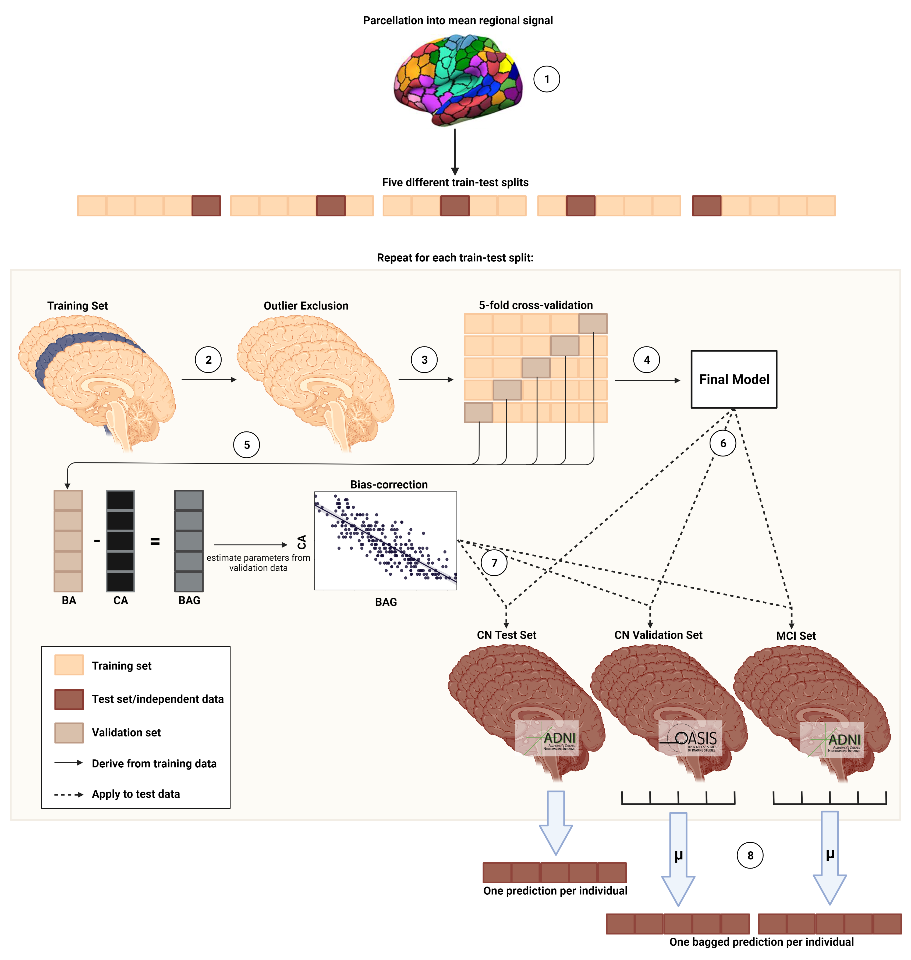

**Fig 1. Nested cross-validation approach for brain age prediction.** Five different train-test splits were used to train and test the models. (1) Mean regional gray matter volume or SUVr were inferred from a composite atlas. (2) Outlier exclusion ranges were inferred from the training data, and applied to both the training and test data. (3) Models were trained using five-fold cross-validation. (4) The model with the smallest MAE on the validation folds was chosen as the final model. (5) BA and CA from the validation folds was used to derive bias correction parameters. (6) The final model was subsequently applied to the test sets. (7) Bias correction parameters were applied to predictions in the test set. (8) Mean of predictions across five models is considered as final prediction for CN Validation and MCI set. BA = brain age; CA = chronological age; BAG = brain age gap

**2.3.3 Bias correction**

BPA is subject to a frequently reported bias, in which BPA of older individuals is under- and BPA of younger individuals is overestimated17, regardless of the data or method under consideration18. Several approaches have been suggested for the correction of this bias, which can be broadly summarized into methods including chronological age in the correction and methods not including chronological age in the correction19. Here, bias correction parameters were estimated from BPA in the validation set, and subsequently applied to all test sets. To obtain an in-depth understanding of the effect of the different methods of bias correction on the prediction of CA from MRI and FDG-PET in our data, we implemented bias correction with and without including chronological age17,20. We found that only bias correction with chronological age successfully eliminated the correlation between BPA and chronological age in both MRI and FDG-PET across all five test sets (see Supplementary Materials for a description of bias-correction without CA and Supplementary Table S4 for results of the methodological comparison). The final BPA was therefore calculated under consideration of chronological age, using slope (ɑ) and an intercept (β) as follows:

$${Predicted age}_{corrected with CA}={Predicted age}_{uncorrected}-(α*CA+β)$$

**2.3.4 Precision of brain-predicted age and brain age gap**

As a result of the above described nested cross-validation approach, we obtained five final models per modality. Thus, per modality, we obtained one prediction per (non-outlier) subject in the CN sample (n = 345), and five predictions per (non-outlier) subject in the CN_validation (rangen = [52, 54]) and MCI sample (n = 513). For each individual, BAG was calculated as BPA – CA. MAE and average BAG of all samples was compared between modalities using a paired t-test.

**2.4 Associations of brain age gap with cognitive performance, Alzheimer’s disease neuropathology, and cognitive decline**

To assess whether BAG is associated with cognitive performance, we calculated partial correlations between BAG and composite scores of memory (ADNI-MEM21), and executive function (ADNI-EF22), while correcting for age, sex, years of education and APOE-ε4 carriership status. The correlations were tested against a Bonferroni-corrected alpha level of .025 (0.05/2). ADNI-MEM combines several scores used to evaluate individuals’ memory performance from the Rey Auditory Verbal Learning Test, Alzheimer’s Disease Assessment Scale and Mini Mental State Exam. ADNI-EF is a summary score of several executive function tasks, including: Category Fluency, Trails, Digit span backwards, Wechsler Adult Intelligence Scale-R Digit Symbol Substitution, Number Cancellation, and Clock Drawing items.

To assess whether BAG is associated with AD neuropathology, we calculated partial correlations between BAG and PET amyloid load (AV45-PET), as well as amyloid, tau and phosphor-tau accumulation in cerebrospinal fluid (CSF), while correcting for age, sex, years of education and APOE- ε4 carriership. The Bonferroni-corrected alpha level was set to 0.0125 (0.05/4). For AV45-PET, mean SUVr are publicly available from previous analyses23–26. CSF measures of amyloid, tau and phospho-tau were acquired via lumbar puncture and analyzed using the Roche Elecsys® beta-Amyloid1-42, Total Tau and Phospho Tau181p immunoassays27. The number of tau PET scans already evaluated for SUVr in the current cohorts was too small to include this biomarker into the current analyses.

Finally, we trained a logistic regression classifier to predict cognitive outcome within two years. Cognitive outcome was a binary variable (“stables” vs. “decliners”), based on the final diagnosis after two years. Thus, CN who received a diagnosis of MCI or AD within two years were cognitive *decliners*, while CN who maintained the CN diagnosis until 24 months after BAG assessment yielded the group of *stables*. For MCI, decliners were those individuals who progressed to ‘probable AD’ within two years. Probable AD at follow-up entailed presence of dementia symptoms, abnormal memory and cognitive function and fulfillment of NINCDS/ADRDA criteria for probable AD. MCI patients who were diagnosed as CN after two years were disregarded in the current analyses (n=29). Both in CN and MCI, we extracted a semi-random sample of stables, matched in number, age and sex to the complete cohort of decliners. MRI- and FDG-derived BAG in these samples, together with amyloid status (CSF amyloid1-42 <= 1100 pg/ ml28), APOE-ε4 carriership and years of education, were used as input to predict cognitive outcome using a 10-fold cross-validated logistic regression classifier, as depicted in **Fig 2**. Significant predictors of cognitive outcome were recorded. For each validation fold, the logistic regression classifier yielded an estimated probability of diagnosis change within two years. To derive a BAG threshold for elevated risk of a change in cognitive diagnosis, a logistic curve was fitted to model the relationship between BAG estimated from the significant BAG, and estimated probability of diagnosis change. The intercept of this curve at 50% probability was set as a threshold and validated in the current (ADNI), as well as the DELCODE sample.

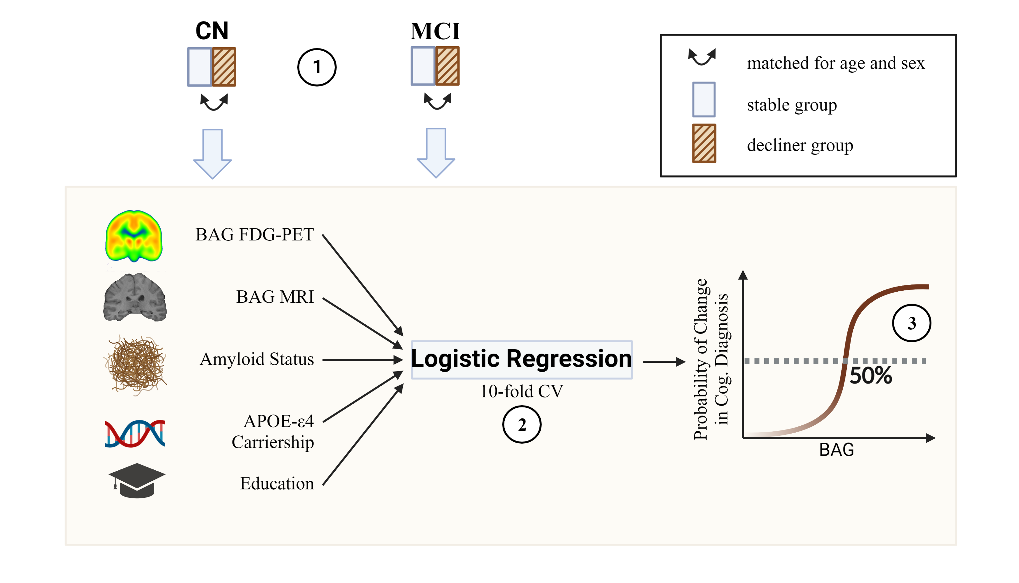

**Fig 2. Estimation of a BAG threshold for cognitive decline.** (1) A stable group was created matched in age and sex to the group of all decliners in CN or MCI. (2) 10-fold cross-validated prediction of cognitive decline within two years was conducted with FDG-PET and MRI BAG, as well as amyloid status, APOE-ε4 carriership and education as predictors. (3) The BAG threshold for increased risk of cognitive decline was inferred from 50% probability of a change in cognitive diagnosis in the cross-validated classification output.

**3 Results**

**3.1 Participants**

This study included 972 MRI and FDG-PET scans (respectively) from the ADNI database (CN+SCIADNI: n = 376; MCIADNI: n = 596), as well as data from two validation cohorts. To validate brain age estimation, we used 59 MRI and FDG-PET scans (respectively) of CN from the OASIS-3. To validate BAG thresholds for the prediction of cognitive outcome, we used 88 FDG-PET scans of SCI and 80 MRI scans of MCI patients from DELCODE. An overview of participant characteristics is presented in **Table 1**. In the cognitively unimpaired cohorts, CNOASIS and SCIDELCODE were significantly younger than CN+SCIADNI (t = 3.44, *p* < .001), especially in the MRI cohort, and the MMSE of SCIDELCODE was higher compared to CN+SCIADNI (t = -2.30, *p* = .03). Among MCI samples, MCIDELCODE had significantly less years of education (t = 6.01, *p* < .001)

**3.2 Precision and demographic profile of brain-predicted age**

To compare the potential of FDG-PET and MRI to predict chronological age, we used a nested five-fold cross-validation approach including bias correction (see **Fig 1**), yielding one test prediction for (almost[3]) every subject in the CN+SCIADNI sample, and a bagged test prediction for the CNOASIS, SCIDELCODE, MCIADNI and MCIDELCODE samples. Across the CN+SCIADNI test samples (n = 357 after outlier exclusion), MRI and FDG-PET predicted chronological age with a mean absolute error (MAE) of 1.96 and 2.63 years, and a broad range of BAG spanning 16 and 18.7 years, respectively (see **Table 2**). Both, MRI- and FDG-PET-derived BAG were normally distributed and they were moderately strongly correlated (r = .288, *p* < 0.001). In the external CNOASIS sample (n=52 after outlier exclusion), bagged predictions of chronological age had an MAE of 2.23 and 2.03 years for MRI and FDG-PET, respectively, thus showing high generalization performance of the models to external datasets. SCIDELCODE individuals’ brains were estimated from FDG-PET to be, on average, 2.07 years advanced in age compared to their chronological age. MCIADNI individuals’ brains were estimated to be, on average, 1.51 or 1.07 years advanced in age when predicted from MRI or FDG-PET, and, consistently,

|  |  |  |  |  |  |
| --- | --- | --- | --- | --- | --- |
| **Table 1.** Overview of samples | | | | | |
|  | CN+SCIADNI | CNOASIS | SCIDELCODE | MCIADNI | MCIDELCODE | |
| *n* total | 376 | 59 | 88 | 596 | 80 | |
| Age at PET scan [avg. years (SD)] | 73.9 (5.94) | 71.7**-** (4.22) | 70.9**-** (5.57) | 73.2 (6.93) | NA | |
| Age at MRI scan [avg. years (SD)] | 73.8 (5.92) | 70.36**-** (4.17) | NA | 73.2 (6.92) | 73.4 (5.87) | |
| Sex [%female (nNA)] | 51 (0) | 59 (0) | 41 (0) | 42 (2) | 45 (0) | |
| CSFAβ1-42 Status [%positive (nNA)] | 39 (85) | NA | 43 (28) | 65 (139) | 52 (38) | |
| MMSE [avg. score] | 29 (1.23) | 29 (1.01) | 29**+** (1.03) | 28 (1.75) | 28 (1.67) | |
| Education [avg. years (SD)] | 16 (2.71) | 16 (2.70) | 16**-** (3.00) | 16 (2.67) | 14**-** (3.06) | |
| Notes. Percentage of CSFAβ1-42 Status indicates percentage of amyloid positive individuals among all who received lumbar puncture (excluding NA). Number of individuals who did not receive lumbar puncture for Aβ1-42 is in parentheses. +significantly higher than CN+SCIADNI, -significantly lower than CN+SCIADNI. Comparisons done within modality and group, via t-test for numeric, and χ² for categorical variables, with α = 0.05. | | | | | | |

MCIDELCODE individuals’ brains were estimated to be 1.42 years older than their chronological age. Bias correction eliminated the correlation between BAG and chronological age in the CN+SCIADNI, CNOASIS, both DELCODEsamples, although a marginal (α=0.1) correlation remained between BAG and chronological age in the CNOASIS sample (MRI: r = -.242, *p* = .08, FDG-PET: r = .266, *p* = 0.06).

Women showed lower BAG compared to men in CN+SCIADNI (tMRI = -6.98, *pMRI* < .0001, tFDG-PET = -1.98, *pFDG-PET* = .05), SCIDELCODE (tFDG-PET = -2.13, *p* = 0.04), MCIADNI (tFDG-PET = -3.85, *pFDG-PET* < .001; tMRI = -5.58, *pMRI* < .0001), and MCIDELCODE (tMRI = -2.73, *pMRI* < .008), especially on MRI-derived BAG. Carriership of the APOE-ε4 allele, genetically predisposing for Alzheimer’s disease, was associated with higher BAG in MCIADNI (only MRI: tMRI = 2.72, *pMRI*= 0.007). Years of education was not correlated with BAG in any of the samples.

All final models were SVMs, and four out of five, and five out of five final used a linear kernel. To assess feature importance (δ) in the brain age prediction paradigm, we extracted all brain region’s weight coefficients as learned by these models. For non-linear kernels, weight coefficients are not available. Regional weight coefficients were strongly correlated within modalities (MRI: r = [.79, 0.89]), FDG-PET: r = [.74, .79], but average weight coefficients were not correlated between the two modalities (r = .048, *p* = .48), i.e. the regions used for brain age prediction in the two modalities were substantially different (see **Fig 3**). For FDG-PET (range: [-0.99 (right globus pallidus), 1.04 (right caudate nucleus)]), important regions (very low or very high weight coefficient) included temporal, pre-frontal, and sub-cortical regions (e.g., globus pallidus, nucleus accumbens, and caudate nucleus). Notably, SUVR in all highly important regions in FDG-PET (mean(δ) + 2*SD(δ) > δ < mean(δ) - 2*SD(δ)) were right hemispheric, and negatively correlated with chronological age. For MRI (range: [-0.30 (right hippocampus), 0.22 (right visual network)]), important regions included parietal, pre-frontal, occipital, and sub-cortical regions (e.g., hippocampus, nucleus accumbens, globus pallidus, and caudate nucleus). Again, the majority of highly important regions was right hemispheric and negatively correlated with age. A full list of highly important regions with correlation results can be found in the Supplementary materials, section Feature Importance.

|  |  |  |  |  |  |  |  |  |
| --- | --- | --- | --- | --- | --- | --- | --- | --- |
| **Table 2.** Precision of predicting chronological age from FDG-PET and MRI scans. | | | | | | |  |  |
|  | CN+SCIADNI | | CNOASIS | | MCIADNI | | SCIDELCODE | MCIDELCODE |
|  | MRI | FDG | MRI | FDG | MRI | FDG | FDG | MRI |
| *n* total | 357⁺ | 357⁺ | 52⁺ | 52⁺ | 596 | 596 | 88 | 80 |
| MAE | 1.96 | 2.63 | 2.23 | 2.03 | 2.62 | 2.51 | 2.64 | 2.62 |
| Range | [-6.91, 9.09] | [-8.72, 9.98] | [-5.44, 7.40] | [-6.70, 5.46] | [-9.07, 9.55] | [-10.91, 9.23] | [-5.49, 7.92] | [-4.64, 9.60] |
| ME | 0.05 | -0.001 | -0.71 | -0.04 | 1.51 | 1.07 | 2.07 | 1.42 |
| R² | .816 | .693 | .593 | .617 | .773 | .794 | .641 | .676 |
| *Notes.* +After outlier exclusion using CN train set (IQR > 6). Precision of bagged predictions are shown for all but the CN+SCIADNI samples. | | | | | | | | |

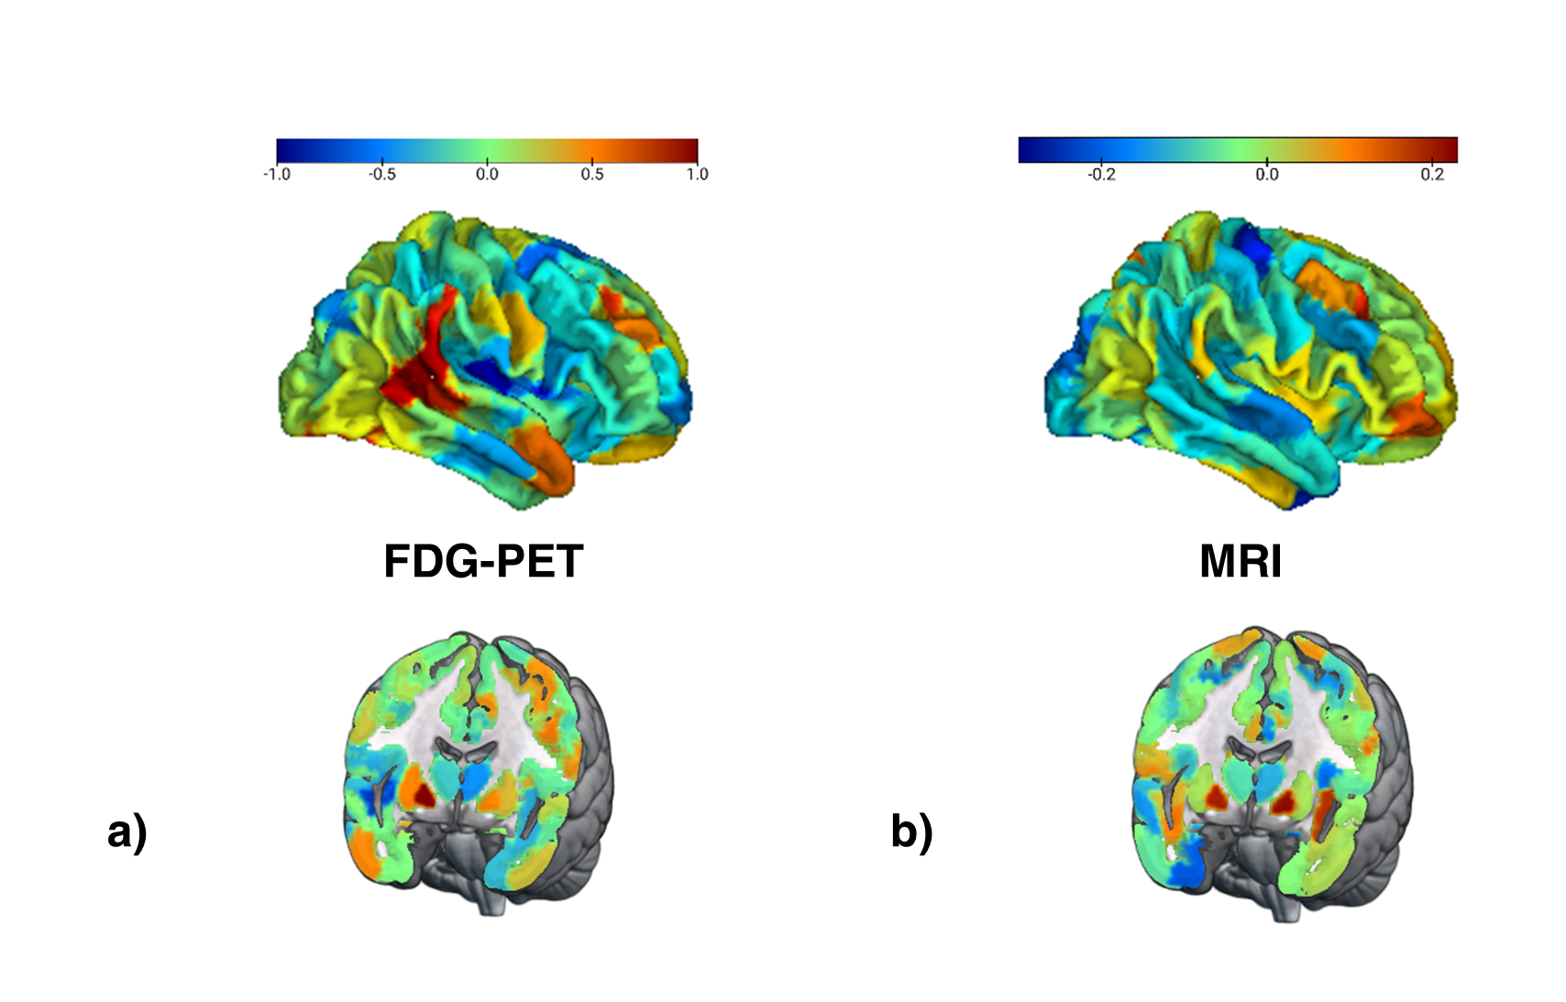

**Fig 3** **Feature importance for brain age prediction.** a) Average weights of support vector regression across three linear SVR for brain age prediction using FDG-PET. Weights were highly correlated across models (r > 0.7). b) Average weights of support vector regression across five linear SVR for brain age prediction using MRI. Weights were highly correlated across models (r > 0.7).

**3.3 BAG and Cognitive Performance**

Partial correlations between BAG and composite scores for memory (ADNI-MEM) and executive function scores (ADNI-EF) were calculated to evaluate whether BAG is associated with cognitive performance in the two modalities using the ADNI samples. To adjust for multiple comparisons, threshold levels of significance were adjusted by Bonferroni correction (α = .025), while p-values below .10 were considered “marginal” and are reported for interpretability. Age, sex, years of education and APOE-ε4 were entered as covariates.

In CN, ADNI-MEM (*p* = .64) and ADNI-EF (*p* = .13) scores were normally distributed as assessed with the Shapiro Wilk test, thus, Pearson correlations were computed. Higher MRI-derived BAG was associated with lower ADNI-EF scores (r = -.137, *p*= .01). A marginal, negative correlation was observed between FDG-PET-derived BAG and ADNI-MEM scores (r = -.100, *p* = .06).

In MCI, ADNI-MEM (*p* = .004) and ADNI-EF (*p* = .05) were not normally distributed as assessed with the Shapiro Wilk test, thus, Spearman-rank correlations were assessed. Both, MRI- and FDG-PET-derived BAG were significantly negatively correlated with ADNI-MEM (rhoMRI = -.379, *pMRI <* .0001; rhoFDG-PET = -.237, *pFDG-PET* < .0001) and ADNI-EF (rhoMRI = -.272, *pMRI <* .0001; rhoFDG-PET = -.243, *pFDG-PET*  < .0001).

**3.4 BAG and AD Neuropathology**

Partial correlations between BAG and PET amyloid status (global AV45), CSF β-amyloid1–42 (CSF Aβ1-42), CSF total-tau (CSF Tau) and CSF phospho-tau181 (CSF pTau181) were calculated to evaluate whether BAG is associated with AD neuropathology in the two modalities using the ADNI sample. To adjust for multiple comparisons, threshold levels of significance were adjusted by Bonferroni correction (α = .0125), while p-values below .05 were considered “marginal”. Again, age, sex, years of education and APOE-ε4 were entered as covariates. None of the neuropathological indicators were normally distributed in either CN or MCI, therefore Spearman-rank correlations were computed.

In CN+SCIADNI, higher MRI- and FDG-PET-derived BAG were both correlated with a decrease in CSF Aβ1-42 (rhoMRI = -.152, *pMRI* .012; rhoFDG-PET = -.152, *pFDG-PET* = .012), but none of the other pathological variables. In MCIADNI, both, higher MRI- and FDG-PET-derived BAG were associated with enhanced amyloid accumulation, as reflected by significant negative correlations with CSF Aβ1-42 (rhoMRI = -.232, *pMRI <* .0001; rhoFDG-PET = -.144, *pFDG-PET* = .002), and (marginal) positive correlations with global AV45 (rhoMRI = -.272, *pMRI <* .0001; rhoFDG-PET = -.1, *pFDG-PET*  = .026). Moreover, higher MRI-derived BAG was marginally associated with higher levels of CSF pTau181 (rhoMRI = .093, *pMRI* = .048).

**3.5 BAG and Cognitive Outcome**

To assess the potential of BAG from the two modalities to serve as an indicator of cognitive outcome, and to calculate thresholds for elevated risk of cognitive decline in CN and MCI, cognitive outcome after two years was predicted from MRI- and FDG-PET-derived BAG, APOE-e4 carriership, CSF amyloid status and years of education. We applied 10-fold cross-validated logistic regression in a subsample containing all decliners, and an equal number of stables matched in age and sex for both, CN and MCI. Predictors were considered significant at α = .05. As amyloid status was not available for all individuals, analyses were conducted in two ways: once including individuals with missing amyloid information (NA values coded as 0, and amyloid negativity coded as reference; “whole samples”), and once excluding these individuals (“complete samples”, results in Supplementary Materials).

Two hundred seventy eight individuals from the CN+SCIADNI sample remained stable until year two, while 30 obtained a diagnosis of cognitive impairment (MCI or dementia) within two years. Consequently, a subsample of 30 stables and all 30 decliners constituted the subsample for prediction of cognitive outcome in CN. We found that, holding all other predictor variables constant, FDG-PET-derived BAG and APOE-ε4 carriership significantly predicted cognitive outcome after two years. The odds of a change in diagnosis for the worse within two years were increased by 29% (95% CI [1.079, 1.604], *p* = .010) for every FDG-PET-derived BAG year. Moreover, these odds were also increased by 835% (95% CI [1.496, 71.814], *p* = .028) for APOE-ε4 carriers, compared to non-carriers. To obtain a cut-off for cognitive outcome, we fit a logistic regression model on cognitive outcome by BAG on FDG-PET. The intersection of the curve with 50% probability of receiving such a diagnosis was at 0.78 years FDG-PET BAG (see **Fig. 4**). This suggests that if the brain age of a cognitively unimpaired individuals is advanced by 0.85 years, they have an elevated risk of cognitive decline. In the current CN+SCIADNI subsample, stratification by this cut-off yielded a specificity of 70.0% and a sensitivity of 66.7%. To validate the cut-off in an external dataset, we applied it to the SCIDELCODE cohort (ndecliners= 8, nstables =

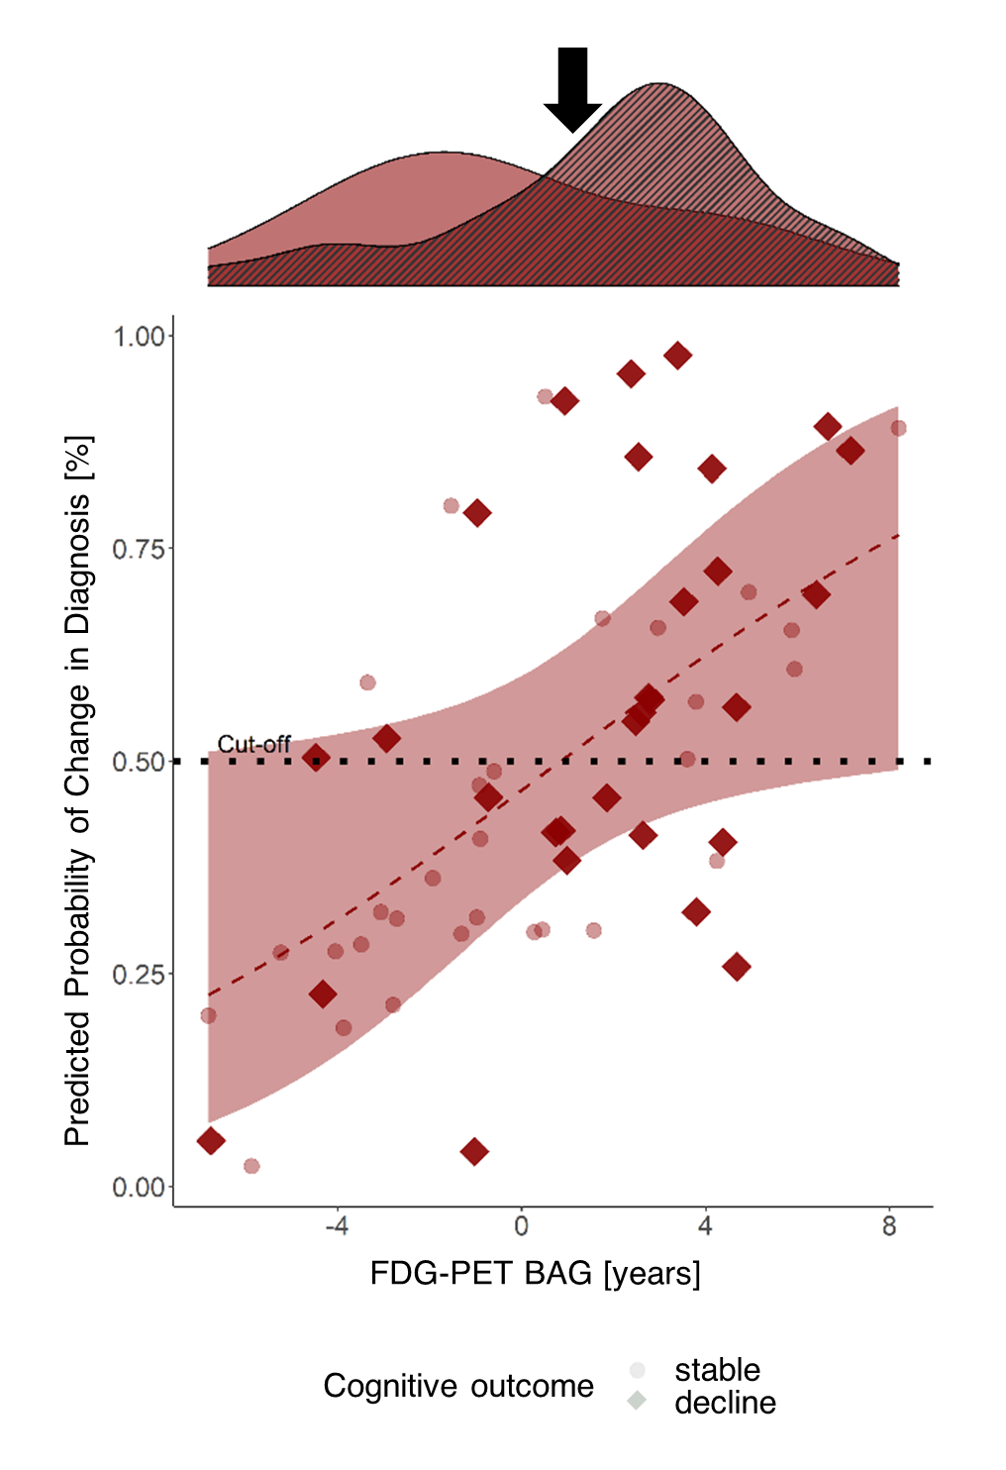

**Fig. 4** **Cross-validated probability of a change in diagnosis from CN/SCI to MCI/Dementia within two years by FDG-PET BAG.** Probability was estimated by fitting a logistic regression model on cognitive outcome by FDG-PET BAG, MRI BAG, amyloid status, apoe-e4 carriership and years of education. The red line shows the logistic regression on cognitive outcome by FDG-PET BAG, with the shaded area representing standard error. The red line intersects 50% at 0.85 years BAG on FDG-PET. The density plot above shows FDG-PET BAG distribution of stables (clear) and decliners (striped) in the subsample and the black error points to the cutoff.

80), where we obtained a specificity of 87.5% and a sensitivity of 33.8%.

After removing those individuals who did not have information on amyloid status available (n=6), a complete sample of 24 decliners remained, thus constituting a sample size of 48. Results from the complete samples were largely consistent with results obtained from the whole samples and can be found in the Supplementary Materials, section “Prediction of Cognitive Outcome”.

Three hundred forty eight MCI patients remained stable until year two, while 113 MCI patients converted to dementia. Consequently, a subsample of 113 stables and all 113 decliners constituted the subsample for prediction of cognitive outcome in MCI. Holding all other predictor variables constant, MRI-derived BAG, a positive amyloid status in CSF, and APOE-ε4 carriership significantly predicted cognitive outcome after two years. With every one-year increase in BAG on MRI, the odds of converting to MCI or dementia were increased by 52% (95% CI [1.304, 1.788]), while a positive amyloid status and APOE-ε4 carriership increased those odds by 411% (95% CI [1.632, 11.255]) and 303% (95% CI [1.495, 6.254]), respectively. To obtain a cut-off for cognitive outcome, we fit a logistic regression model on cognitive outcome by MRI BAG. The intersection of the curve with 50% probability of receiving such a diagnosis was at 2.14 years MRI BAG (see **Fig. 5**). Again, this suggests that if the brain age of an MCI patient is advanced by at least this cut-off value, they have an elevated risk of conversion to dementia. In the current MCIADNI subsample, stratification by this cut-off yielded a specificity of 73.5% and a sensitivity of 71.7%. In the MCIDELCODE sample (nstables = 41, ndecliners = 28), the cut-off had a comparable specificity of 67.9% and a sensitivity of 73.2%.

Three hundred sixty nine MCI patients had full information on all considered variables, thus constituting the decliner group of the complete samples. Results from the complete samples were largely consistent with results obtained from the whole samples and can be found in the Supplementary Materials. Finally, given the correlation observed between FDG-PET- and MRI BAG, we additionally assessed logistic regression models with unimodal BAG29. Considered in separate models, both MRI- and PET-BAG very significantly predicted Cognitive Outcome in MCIADNI, while only FDG-PET predicted cognitive outcome in CN+SCIADNI (see Supplementary Tables S2 and S3 for estimates of logistic regression in whole samples).

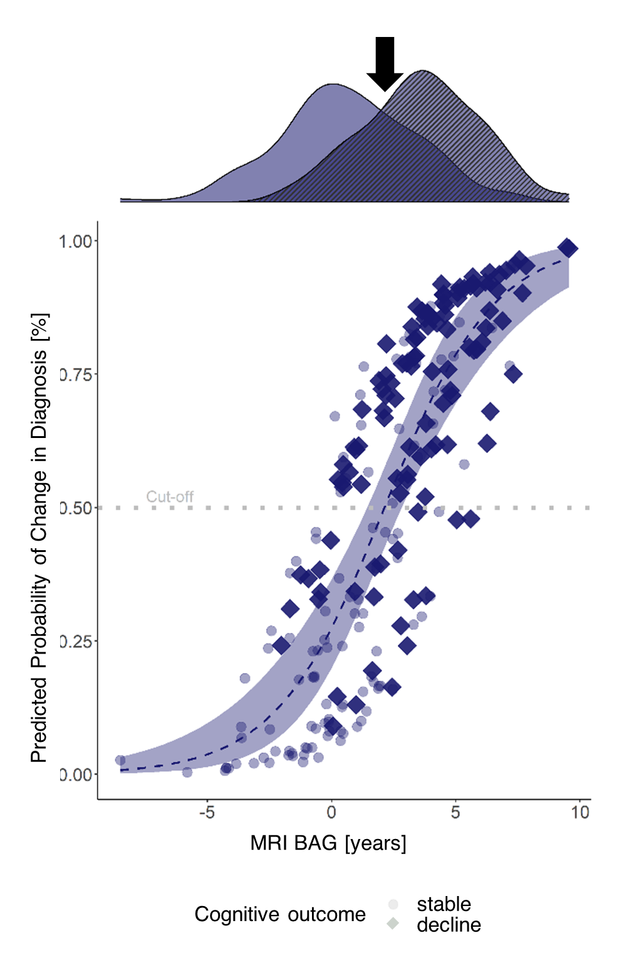

**Fig. 5 Cross-validated probability of cognitive decline within two years after a baseline diagnosis of MCI by MRI-BAG.** Probability was estimated by fitting a logistic regression model on cognitive outcome by FDG-PET BAG, MRI BAG, amyloid status, apoe-e4 carriership and years of education. The blue line shows the logistic regression on cognitive outcome by MRI BAG, with the shaded area representing standard error. The blue line intersects 50% at 2.14 years BAG on FDG-PET. The density plot above shows FDG-PET BAG distribution of stables (clear) and decliners (striped) in the subsample and the black error points to the cutoff.

**4 Discussion**

While numerous works exist on the relationship between brain age and neurodegenerative diseases, cut-offs and recommendations for BAG as an individual-level biomarker of cognitive outcome were only sparsely investigated. However, investigation on how brain age can used as a biomarker, and what it reflects, is critical to effectively use the extensive body of literature on brain age in clinical practice. Here, we showed that 1) MRI and FDG-PET both predict chronological age well, 2) MRI and FDG-PET-derived BAG both depict neuropathological abnormality in CN/SCI and MCI, as well as cognitive dysfunction in MCI, and 3) that BAG derived from FDG-PET enables prognoses of cognitive outcome in CN/SCI, while MRI does the same in MCI. We further offered cut-offs for enhanced risk of cognitive decline within two years. While the potential of both MRI and FDG-PET to estimate brain age has proven previously4, the current study confirms this finding under consideration of the two modalities in absolute independence (i.e., without using information from one modality for pre-processing of the other, e.g. for partial volume correction).

Congruent with previous work, our findings suggest that FDG-PET shows greater and more consistent changes related to early and subtle neurodegeneration-associated changes in the brain. MRI, on the other hand, excelled is superior in delineating AD-related changes with an AD diagnosis (e.g. onset of tau-related neurodegeneration)8. Among the CN population, our results are likely most relevant to individuals experiencing SCI, who are assumed to recognize cognitive deficits before they become objectively measurable30, more likely to develop MCI or AD compared to CN31, and who are the individuals who a clinical context would be seen by a physician. Prediction of cognitive outcome in this cohort based on FDG-PET BAG was moderately to highly specific, while sensitivity was low. Consistently, Lee and colleagues showed that FDG-PET BAG is significantly increased in CN converting to MCI or AD at baseline4. Together, these findings deliver strong evidence that FDG-PET BAG could aid in the identification of at-risk individuals (i.e., those who have a BAG above our proposed cutoff), while further information must be gathered for individuals with SCI with a BAG below the cutoff. The establishment of a gatekeeping system for cognitive prognoses in SCI in clinical practice, similar to our recent research in MCI32 offers a promising avenue for future research.

The inclusion of BAG into clinical trials of AD could have several advantages. Several anti-amyloid therapies are currently under assessment or have recently been approved for the treatment of MCI and early AD. Since cognitive decline is often an outcome factor of these trials, the notion of BAG could help to identify those individuals who are most at risk of cognitive decline, thereby aiding in reducing the number of participants and thus cost and time of treatment trials. Moreover, BAG is an established summary marker of brain health33 and reflects various neurological abnormalities beyond AD34,35. In line with that, beyond its prognostic value, we have shown that BAG is associated with amyloid load, regardless of modality or group, and that in MCI, both MRI and FDG-PET BAG depict impairment of memory and executive function. The inclusion of BAG as a summary measure of overall brain health as a secondary outcome variable could provide useful additional information on drug efficacy.

The biological plausibility of our models becomes evident from the consideration of feature importance. We found a spatial disconnect between aging as observed on FDG-PET and MRI, which is in line with previous research by Dukart and colleagues8. Moreover, the regions deemed most important by our MRI model ((mostly right-hemispheric) parietal, pre-frontal, occipital, and sub-cortical regions, including caudate nuclei and the hippocampus) have all been described to be substrates heavily affected by aging on MRI in the same paper. While Dukart and colleagues also found prefrontal involvement in normal aging on FDG-PET, our FDG-PET model additionally found temporal and subcortical regions useful in estimating brain age. Notably, most of the highly age-affected brain regions on MRI and all on FDG-PET were right hemispheric, thus supporting the often postulated idea that the right hemisphere exhibits greater age-related decline36,37. Moreover, temporal, parietal, and pre-frontal regions are strongly affected by AD38. Since these regions were also highly relevant in estimating brain age by our current models, our work supports the claim that AD-related neurodegeneration is a form of advanced brain aging.

Some limitations should be acknowledged. First, the sensitivity and especially specificity values of FDG-PET BAG for prognoses in cognitively unimpaired individuals, as well as of MRI BAG for prognoses in MCI patients, are not high enough for these measures to be used as a stand-alone biomarker of cognitive outcome. However, accurate prognoses, especially for cognitively unimpaired individuals, are rare and we believe that brain age with a group-dependent choice of modality can support this process. In the future, it will be interesting to assess the combined potential of e.g., FDG-PET BAG and APOE-ε4 carriership as a prognostic biomarker of cognitive outcome. Unfortunately, in our sample, this analysis was not available, as it would have introduced feature leakage, and thus, biased predictions. A second limitation is in the fact that is not a straightforward to acquire neuroimaging, and especially FDG-PET scans from a CN population, as PET scans require logistic availability, comparably high cost, and the injection of a radioactive tracer. Whether the multi-dimensional feature space of FDG-PET can be replaced by easier accessible fluid biomarkers of neurodegeneration, and whether they would reflect brain aging, is debatable and an intriguing matter for future research. Moreover, the average BAG (ME) of SCIDELCODE exceeds previously reported BAG on MRI (1.1 years3). These differences possibly are due to a combination of factors, including different choice of modality, as we used FDG-PET to estimate brain age of SCIDELCODE. Whether the FDG-PET BAG is abnormally high, or whether higher FDG-PET BAG in SCI reflects very early neurological dysfunction will need further investigation. Finally, our definition of CN only required for the absence of objective cognitive impairment, but not normality according to specific biomarkers, thus, participants with and without underlying amyloid pathology were included into our training sample, which could possibly have introduced a confound. However, here the choice was to train our models to capture potential pathological heterogeneity of cognitively normal individuals to obtain a realistic estimate of brain aging.

In conclusion, we have shown that FDG-PET and MRI can both be used for brain age prediction and have different advantages depending on the group under investigation: While both, MRI- and FDG-PET BAG accurately reflect neuropathological burden across groups and cognitive performance in MCI, FDG-PET BAG can support prognoses of cognitive outcome in cognitively unimpaired individuals. BAG on MRI, on the other hand, better allows for an estimation of risk of dementia in MCI. By means of our BAG cutoffs, cognitive outcome can be estimated, which in turn could support the identification of patients in need of frequent monitoring at an early time point, as well as support clinical trials, both methodologically, and financially.

**References**

1. Nie, C. *et al.* Distinct biological ages of organs and systems identified from a multi-omics study. *Cell Rep.* **38**, (2022).

2. Beheshti, I., Mishra, S., Sone, D., Khanna, P. & Matsuda, H. T1-weighted MRI-driven brain age estimation in Alzheimer’s disease and Parkinson’s disease. *Aging Dis.* **11**, (2020).

3. Rokicki, J. *et al.* Multimodal imaging improves brain age prediction and reveals distinct abnormalities in patients with psychiatric and neurological disorders. *Hum. Brain Mapp.* **42**, (2021).

4. Lee, J. *et al.* Deep learning-based brain age prediction in normal aging and dementia. *Nat. Aging* (2022) doi:10.1038/s43587-022-00219-7.

5. Löwe, L. C., Gaser, C. & Franke, K. The effect of the APOE genotype on individual BrainAGE in normal aging, Mild cognitive impairment, and Alzheimer’s Disease. *PLoS One* **11**, (2016).

6. Gaser, C., Franke, K., Klöppel, S., Koutsouleris, N. & Sauer, H. BrainAGE in Mild Cognitive Impaired Patients: Predicting the Conversion to Alzheimer’s Disease. *PLoS One* **8**, (2013).

7. Jack, C. R. *et al.* Hypothetical model of dynamic biomarkers of the Alzheimer’s pathological cascade. *The Lancet Neurology* vol. 9 119–128 (2010).

8. Dukart, J. *et al.* Generative FDG-PET and MRI Model of Aging and Disease Progression in Alzheimer’s Disease. *PLoS Comput. Biol.* **9**, e1002987 (2013).

9. LaMontagne, P. J. *et al.* OASIS-3: Longitudinal neuroimaging, clinical, and cognitive dataset for normal aging and Alzheimer disease. *medRxiv* (2019) doi:10.1101/2019.12.13.19014902.

10. Verger, A., Doyen, M., Campion, J. Y. & Guedj, E. The pons as reference region for intensity normalization in semi-quantitative analysis of brain 18FDG PET: application to metabolic changes related to ageing in conventional and digital control databases. *EJNMMI Res.* **11**, 1–7 (2021).

11. Jack, C. R. *et al.* The Alzheimer’s Disease Neuroimaging Initiative (ADNI): MRI methods. *Journal of Magnetic Resonance Imaging* vol. 27 (2008).

12. Pedregosa, F. *et al.* *Scikit-learn: Machine Learning in Python Gaël Varoquaux Bertrand Thirion Vincent Dubourg Alexandre Passos PEDREGOSA, VAROQUAUX, GRAMFORT ET AL. Matthieu Perrot*. *Journal of Machine Learning Research* vol. 12 http://scikit-learn.sourceforge.net. (2011).

13. Schaefer, A. *et al.* Local-Global Parcellation of the Human Cerebral Cortex from Intrinsic Functional Connectivity MRI. *Cereb. Cortex* **28**, (2018).

14. Tian, Y., Margulies, D. S., Breakspear, M. & Zalesky, A. Hierarchical organization of the human subcortex unveiled with functional connectivity gradients. *bioRxiv* (2020) doi:10.1101/2020.01.13.903542.

15. Suzman, R. & Riley, M. W. Introducing the ‘oldest old’. *Milbank Mem. Fund Q. Health Soc.* **63**, (1985).

16. Beheshti, I. *et al.* Predicting brain age using machine learning algorithms: A comprehensive evaluation. *IEEE J. Biomed. Heal. Informatics* (2021) doi:10.1109/JBHI.2021.3083187.

17. Beheshti, I., Nugent, S., Potvin, O. & Duchesne, S. Bias-adjustment in neuroimaging-based brain age frameworks: A robust scheme. *NeuroImage Clin.* **24**, (2019).

18. Liang, H., Zhang, F. & Niu, X. Investigating systematic bias in brain age estimation with application to post-traumatic stress disorders. *Hum. Brain Mapp.* **40**, (2019).

19. de Lange, A. M. G. & Cole, J. H. Commentary: Correction procedures in brain-age prediction. *NeuroImage: Clinical* vol. 26 (2020).

20. Cole, J. H. *et al.* Brain age predicts mortality. *Mol. Psychiatry* **23**, (2018).

21. Crane, P. K. *et al.* Development and assessment of a composite score for memory in the Alzheimer’s Disease Neuroimaging Initiative (ADNI). *Brain Imaging Behav.* **6**, (2012).

22. Gibbons, L. E. *et al.* A composite score for executive functioning, validated in Alzheimer’s Disease Neuroimaging Initiative (ADNI) participants with baseline mild cognitive impairment. *Brain Imaging Behav.* **6**, (2012).

23. Landau, S., Koeppe, R. & Jagust, W. *Florbetaben processing and positivity threshold derivation Motivation for changing the threshold*. (2011).

24. Landau, S. & Jagust, W. *Florbetapir processing methods*. (2011).

25. Jagust, W. J. *et al.* Relationships between biomarkers in aging and dementia. *Neurology* **73**, 1193–1199 (2009).

26. Jagust, W. J. *et al.* The Alzheimer’s Disease Neuroimaging Initiative positron emission tomography core. *Alzheimer’s Dement.* **6**, (2010).

27. Blennow, K. *et al.* Predicting clinical decline and conversion to Alzheimer’s disease or dementia using novel Elecsys Aβ(1–42), pTau and tTau CSF immunoassays. *Sci. Rep.* **9**, (2019).

28. Hansson, O. *et al.* CSF biomarkers of Alzheimer’s disease concord with amyloid-β PET and predict clinical progression: A study of fully automated immunoassays in BioFINDER and ADNI cohorts. *Alzheimer’s Dement.* **14**, (2018).

29. Ranganathan, P., Pramesh, C. & Aggarwal, R. Common pitfalls in statistical analysis: Logistic regression. *Perspect. Clin. Res.* **8**, (2017).

30. Jessen, F. *et al.* A conceptual framework for research on subjective cognitive decline in preclinical Alzheimer’s disease. *Alzheimer’s Dement.* **10**, (2014).

31. Parfenov, V. A., Zakharov, V. V., Kabaeva, A. R. & Vakhnina, N. V. Subjective cognitive decline as a predictor of future cognitive decline a systematic review. *Dement. e Neuropsychol.* **14**, (2020).

32. Doering, E. *et al.* Introducing a Gatekeeping Methodology for Amyloid Status Assessment in Mild Cognitive Impairmenttle. *Eur. J. Nucl. Med. Mol. Imaging*.

33. Cole, J. H., Marioni, R. E., Harris, S. E. & Deary, I. J. Brain age and other bodily ‘ages’: implications for neuropsychiatry. *Molecular Psychiatry* vol. 24 (2019).

34. Eickhoff, C. R. *et al.* Advanced brain ageing in Parkinson’s disease is related to disease duration and individual impairment. *Brain Commun.* **3**, (2021).

35. Wrigglesworth, J. *et al.* Factors associated with brain ageing - a systematic review. *BMC Neurol.* **21**, (2021).

36. Goldstein, G. & Shelly, C. Does the Right Hemisphere Age More Rapidly than the Left? *J. Clin. Neuropsychol.* **3**, (1981).

37. Dolcos, F., Rice, H. J. & Cabeza, R. Hemispheric asymmetry and aging: Right hemisphere decline or asymmetry reduction. *Neurosci. Biobehav. Rev.* **26**, (2002).

38. Bischof, G. N. *et al.* Impact of tau and amyloid burden on glucose metabolism in Alzheimer’s disease. *Ann. Clin. Transl. Neurol.* (2016) doi:10.1002/acn3.339.

**Statements & Declarations**

**Author Contributions**

All authors contributed to the study conception and design. Material preparation, data collection and analysis were performed by ED and GA, in support of KP and MH. KP, TvE, SE and AD jointly supervised this work. The first draft of the manuscript was written by ED and all authors commented on previous versions of the manuscript. All authors read and approved the final manuscript.

**COMPETING INTERESTS**

MH reports no conflict of interest.

**Funding**

Maybe mention SFB?

Data collection and sharing for this project was funded by the Alzheimer's Disease Neuroimaging Initiative (ADNI) (National Institutes of Health Grant U01 AG024904) and DOD ADNI (Department of Defense award number W81XWH-12-2-0012). ADNI is funded by the National Institute on Aging, the National Institute of Biomedical Imaging and Bioengineering, and through generous contributions from the following: AbbVie, Alzheimer's Association; Alzheimer's Drug Discovery Foundation; Araclon Biotech; BioClinica, Inc.; Biogen; Bristol-Myers Squibb Company; CereSpir, Inc.; Cogstate; Eisai Inc.; Elan Pharmaceuticals, Inc.; Eli Lilly and Company; EuroImmun; F. Hoffmann-La Roche Ltd and its affiliated company Genentech, Inc.; Fujirebio; GE Healthcare; IXICO Ltd.;Janssen Alzheimer Immunotherapy Research & Development, LLC.; Johnson & Johnson Pharmaceutical Research & Development LLC.; Lumosity; Lundbeck; Merck & Co., Inc.;Meso Scale Diagnostics, LLC.; NeuroRx Research; Neurotrack Technologies; Novartis Pharmaceuticals Corporation; Pfizer Inc.; Piramal Imaging; Servier; Takeda Pharmaceutical Company; and Transition Therapeutics. The Canadian Institutes of Health Research is providing funds to support ADNI clinical sites in Canada. Private sector contributions are facilitated by the Foundation for the National Institutes of Health ([www.fnih.org](https://ida.loni.usc.edu/collaboration/access/www.fnih.org)). The grantee organization is the Northern California Institute for Research and Education, and the study is coordinated by the Alzheimer's Therapeutic Research Institute at the University of Southern California. ADNI data are disseminated by the Laboratory for Neuro Imaging at the University of Southern California.

1. Data used in preparation of this article were obtained from the Alzheimer's Disease Neuroimaging Initiative (ADNI) database (adni.loni.usc.edu). As such, the investigators within the ADNI contributed to the design and implementation of ADNI and/or provided data but did not participate in analysis or writing of this report. A complete listing of ADNI investigators can be found at: <http://adni.loni.usc.edu/wp-content/uploads/how_to_apply/ADNI_Acknowledgement_List.pdf>
2. Mean and standard deviation indicated from absolute difference in days
3. An outlier exclusion procedure was included in our cross-validation approach. Outlier ranges were estimated based on the training set and test subjects falling in these ranges were subsequently excluded from brain age prediction.